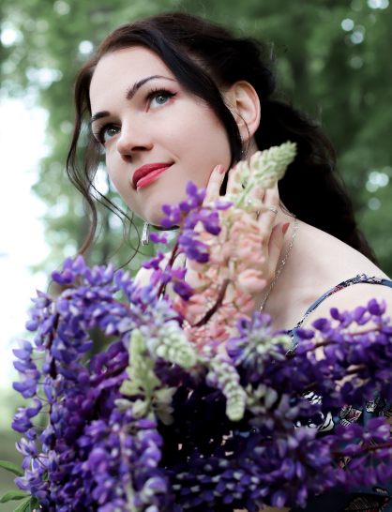

CURRICULUM VITAE
JELENA GARKAVCHENKO
Mezzo-soprano

E-mail: symphoenator@gmail.com
Phone: +371 26749156
Location: Jurmala / Riga, Latvia
Date of birth: August 23, 1986

EDUCATION
2013-2015: Music - Musicology /Music theory (Academic Master Degree) at Jāzeps Vītols Latvian Academy of Music
2009-2013: Music - History and Theory of Music (Professional Bachelor Degree) at Jāzeps Vītols Latvian Academy of Music
2008-2009: English Philology at University of Latvia
2005-2008: Vocal music at Jāzeps Mediņš Riga Music High School
2001-2005: Vocal music - Choir at Jurmala Music School
1993-2005: Secondary general education at Lielupe Secondary School

EMPLOYMENT
2013 - Present: Choir singer (Alto 1) at Latvian National Opera and Ballet
2011-2013: Music Theory teacher (Solfeggio and Musical Form) at Jurmala High School of Music
2007-2013: Concert ticket seller (summer job) at Dzintari Concert Hall

EXTRACURRICULAR ACTIVITIES
2014-2017: Concert annotation writer and translator (RU-LV-ENG) at Inessa Galante Foundation (Riga, Latvia)
Once in a while making RU-LV-ENG translations for different concert projects
Since 2004: Concert singer (opera and chamber music, jazz, popular and folk music)

COURSES
Master courses and private studies with Latvian and foreign vocal coaches: Univ.-Prof. Dr. Barbara Helena Baranowska Zubanovich (Austria), Univ.-Prof. Dr. Michail Lanskoi (Germany, Austria, Italy), Aira Rūrāne (Latvia), Irina Gavrilovici (Austria), Joy Mammen (England), Konstantin Lisovsky and Irina Romishevskaya (Russia), Lidia Jegorova (Latvia).

CERTIFICATES
2019: Certificate of participation in the vocal competition Inessa Galante Talents
2018: Certificate of participation in the vocal competition Inessa Galante Talents
2013: Certificate of participation in students' scientific conference ZinātMāksla∑3

LANGUAGES
Russian - proficiency
Latvian - proficiency
English - advanced
German - intermediate
Italian - elementary
French - beginner

HOBBIES
Argentine Tango (actively dancing 2012-2024)
Perfumery

